Date:

TASK 2: Pauli Matrices and Eigenvalues/Eigenvectors

Aim:

To analyze Pauli matrices through application on qubit states and eigenvalue decomposition.

- Mathematical Model
The Pauli matrices are a set of three 2×2 complex Hermitian and unitary matrices that are widely used in quantum mechanics, particularly in spin systems (spin-1/2 particles), quantum computing, and quantum information theory. They are denoted as σ_{x}​, σ_{y}​, and σ_{z}​, and are defined as follows:
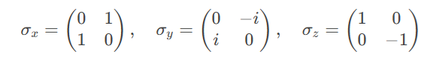

1.1. Eigenvalues and Eigenvectors of the Pauli Matrices

Each Pauli matrix has eigenvalues λ = ±1 and corresponding eigenvectors:

- σ_{x}​ (Pauli-X Matrix)
- Eigenvalues: λ = +1, −1
- Eigenvectors:
- For λ = +1
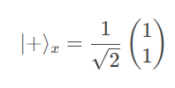
- For λ = −1
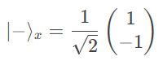
- σ_{y}​ (Pauli-Y Matrix)
- Eigenvalues: λ = +1, −1
- Eigenvectors:
  - For λ = +1
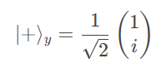

  - For λ = −1
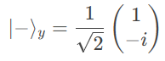

- σ_{z​} (Pauli-Z Matrix)
- Eigenvalues: λ = +1, −1
- Eigenvectors:
  - For λ = +1
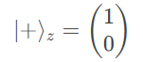

  - For λ = −1
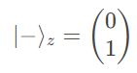

- Observations
- All three Pauli matrices have eigenvalues ±1.
- Their eigenvectors are orthonormal, i.e., ⟨+∣−⟩ = 0 and ⟨±∣±⟩ = 1.
- The eigenvectors of σ_{x}​ and σ_{y}​ are superpositions of the eigenvectors of σ_{z}​, reflecting the non-commutativity of the Pauli matrices ([σ_{i}​,σ_{j}​]=2iϵ_{ijk}​σ_{k}​).

- Physical Interpretation
In quantum mechanics, the Pauli matrices represent spin measurements along the x, y, and z axes for a spin-1/2 particle (like an electron). The eigenvalues ±1 correspond to the possible outcomes of a spin measurement (spin-up or spin-down), and the eigenvectors represent the spin states along the respective axes.

- Algorithm
- Define Pauli-X, Y, and Z matrices.
- Apply these matrices to |0⟩ and |1⟩ states.
- Use linear algebra to compute eigenvalues and eigenvectors.
- Print matrix properties.

- Program
print("\n" + "="*50)
print("TASK 2: PAULI MATRICES AND EIGEN-ANALYSIS")
print("="*50)
# Define Pauli matrices
pauli_x = np.array([[0, 1], [1, 0]])
pauli_y = np.array([[0, -1j], [1j, 0]])
pauli_z = np.array([[1, 0], [0, -1]])
print("Pauli-X matrix:")
print(pauli_x)
print("\nPauli-Y matrix:")
print(pauli_y)
print("\nPauli-Z matrix:")
print(pauli_z)
# Apply to qubit states
qubit_0 = np.array([1, 0]) # |0⟩
qubit_1 = np.array([0, 1]) # |1⟩
print("\nApplying Pauli-X to |0⟩:", pauli_x @ qubit_0)
print("Applying Pauli-X to |1⟩:", pauli_x @ qubit_1)
# Compute eigenvalues and eigenvectors
def analyze_operator(matrix, name):
eigenvals, eigenvecs = eig(matrix)
print(f"\n{name} Eigenvalues:", eigenvals)
print(f"{name} Eigenvectors:")
for i, vec in enumerate(eigenvecs.T):
print(f" λ={eigenvals[i]:.1f}: {vec}")

analyze_operator(pauli_x, "Pauli-X")
analyze_operator(pauli_y, "Pauli-Y")
analyze_operator(pauli_z, "Pauli-Z")

Result
Pauli matrices were applied, and their eigenvalues and eigenvectors were correctly determined.

